**MIS for Computer Science College of SCUT**

**User Manual**

**I. Login and account**

To enter this system, please enter your username and password here. For teachers and students, the username is your ID number and for administrator is ‘admin’. The default password for every account is 123456.

To help testing this program, three testing accounts are provided here.

|  |  |  |
| --- | --- | --- |
| Role | Username | Password |
| Administrator | admin | 123456 |
| Teacher | 20203 | 123456 |
| Student | 2020360223 | 123456 |

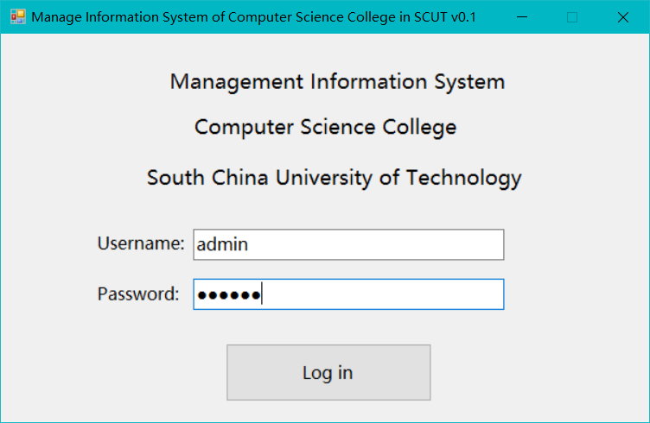

If you want to logout, please click ‘Account’ – ‘Logout/Exit’.

**II. Add record**

II.I Add student record

If you want to add new student, please click ‘Account’ – ‘Add account’ and then set role to student. Then enter new student information and click ‘Add’ to apply adding.

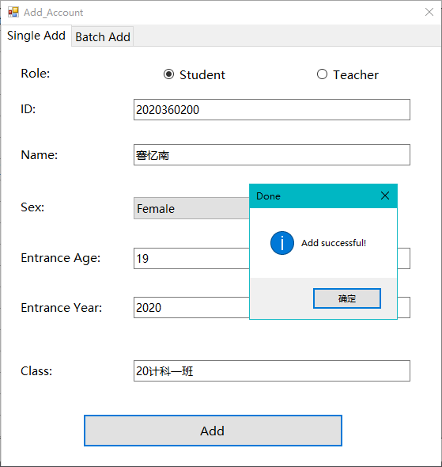

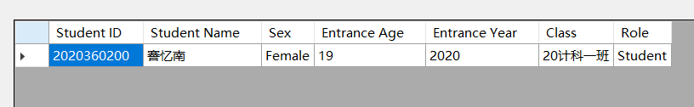

If you need to add multiple students at once, you can use the batch add function. First click the ‘Save Template’ button to save a CSV template, and then add relevant student information to the template. After saving, click the ‘Open CSV’ button to open the modified template file. The information in the file will be displayed in the window. Then click the ‘Add’ button to add student information in the template. The State column will display the status of adding this information. If there is an error in the status, please check whether the corresponding field meets the requirements.

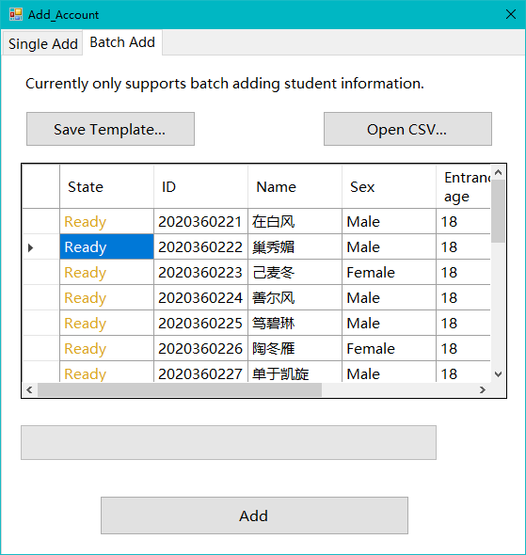

Batching adding result is showed in the following figure.

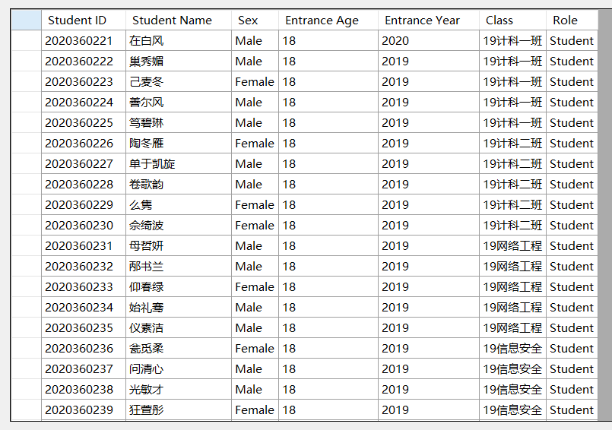

II.II Add teacher record

If you want to add new teacher, please click ‘Account’ – ‘Add account’ and then set role to teacher. Then enter new teacher information and click ‘Add’ to apply adding.

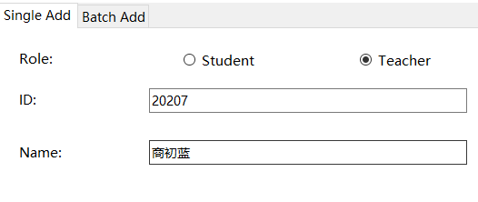

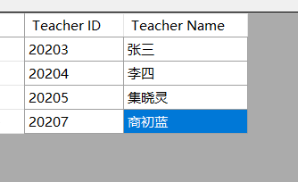

II.III Add course record

To add new course, please click ‘Course – ‘Add course’, then provide the course ID, course name, teacher ID, credit, grade limitation and the canceled year(optional). Then click OK.

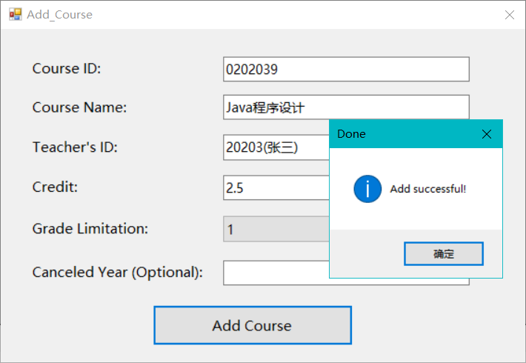

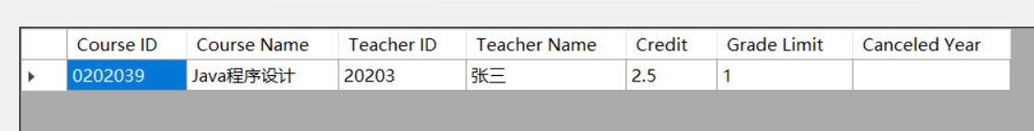

II.IV Add course choosing record

To add new course choosing record, please click ‘Course – ‘Add course choosing info’, then choose the course, teacher, and class from the combo box. Then the ‘Candidate Student’ list view will show all the student in this class. Then you can click ‘Add’ or ‘Add all’ to add them to ‘Chosen Students’ list view. You can also click ‘Delete’ or ‘Delete all’ to remove student from ‘Chosen’ students. Then click ‘Submit’ to submit modification.

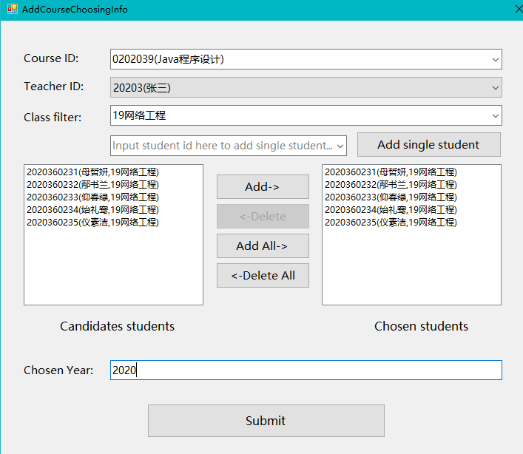

In following window, you can confirm the records which is ready to add. Then click ‘Add’ to apply adding.

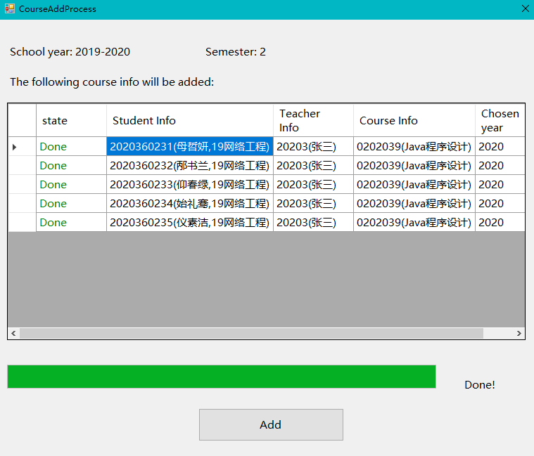

The following figure shows the adding result.

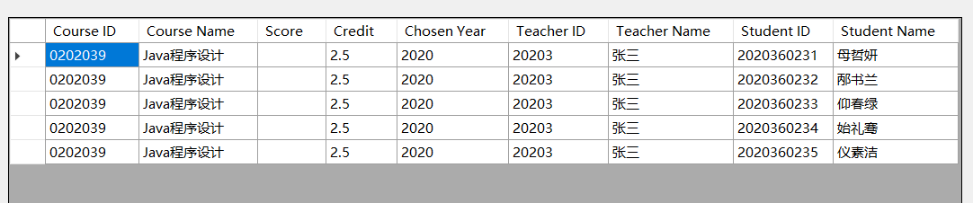

**III. Modify and delete record**

You can click ‘Information’ – ‘Modify Information’ to enter ‘Modify Information’ window, and perform modification here.

III.I Student information record

To modify a single record for a student, you need to input his/her student ID, then click ‘Query’. Then you can see his/her current information. In default, all the new information is same as current information, the administrator can make changes on new information and then apply changes. Or delete this student record.

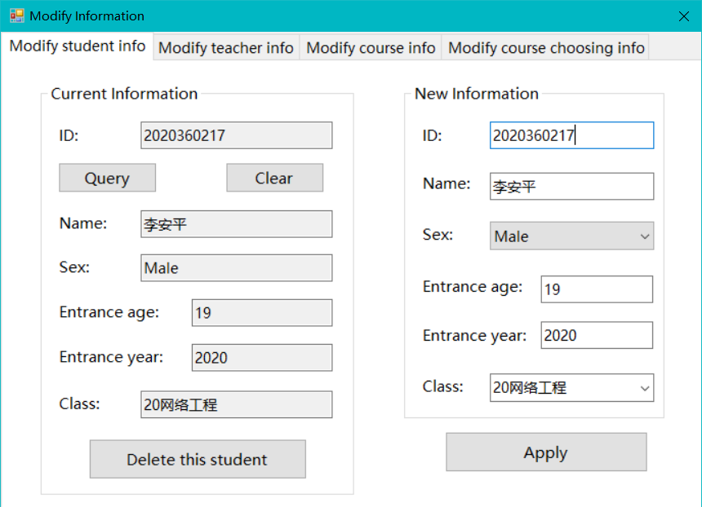

III.II Teacher information record

To modify a single record for a teacher, you need to input his/her teacher ID, then click ‘Query’. Then you can see his/her current information and you can modify or delete this record. These operations are very similar to modify/delete student information.

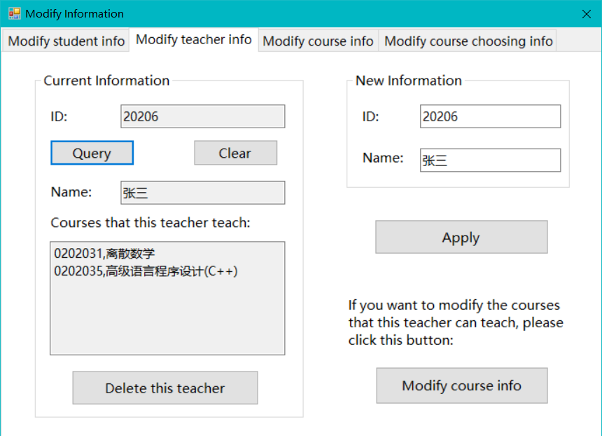

III.III Course information record

To modify a single record for a course, you need to input course ID, then click ‘Query’. Then you can see the current information and you can modify or delete this record. These operations are very similar to modify/delete student information.

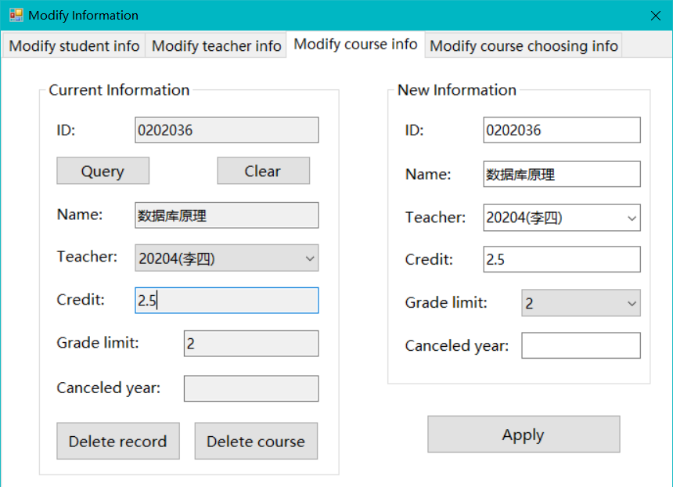

III.IV Course choosing information record

To modify or deleting course choosing record, a student ID should be the query condition, then all the course choosing record of this student will be listed. You can modify or delete target record by clicking corresponding button of the record.

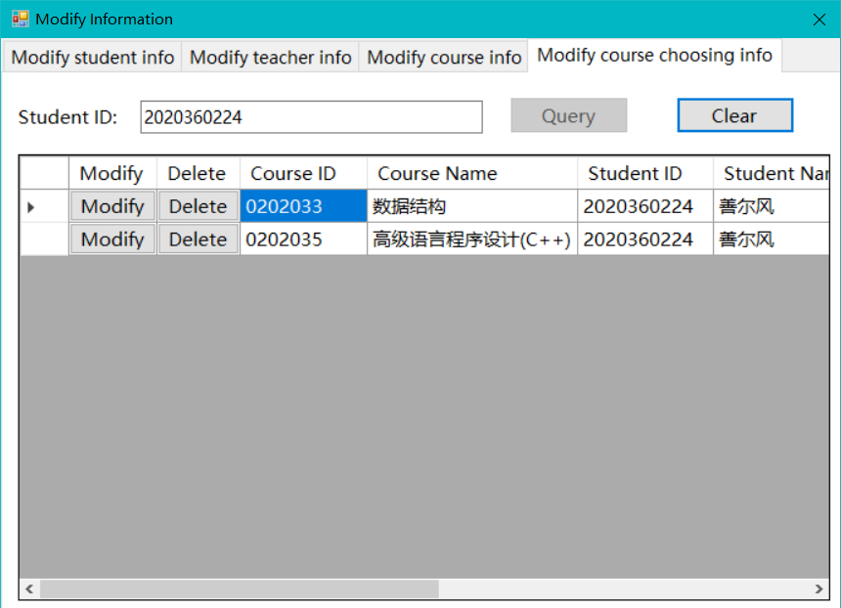

If the administrator wants to delete this record, just click ‘Delete’ and confirm this operation. If he/she wants to modify this record, a new dialog will be showed, which contain all the information about this record. According to authority control principle, the administrator can modify all the attributes of this record except score, as we can see the score text box in ‘New Information’ group box is set to read-only. When the administrator has finished modifying, he/she can click ‘Apply’ button to apply modifying.

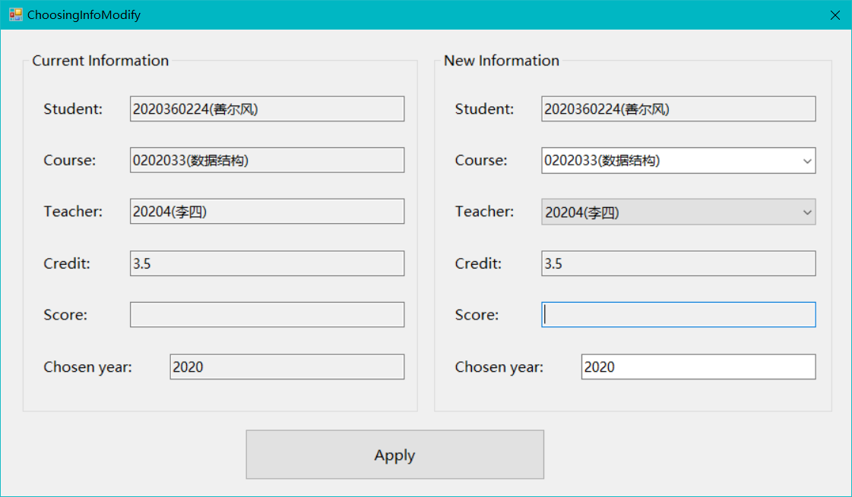

III.V Modify score information

This function is only available for teacher user and each teacher can only modify the grade information of the courses that he/she teaches according to authority control. Just click ‘Course’ – ‘Submit Score’. Then choose a course from the dropdown list and choose correct chosen year.

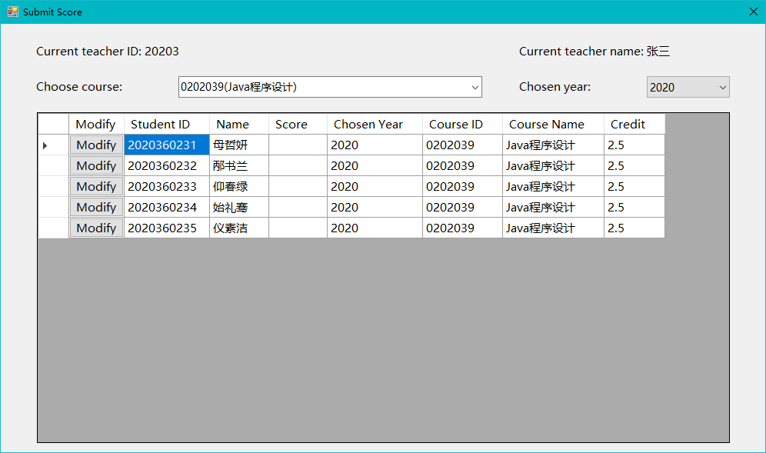

Then the teacher can modify the score information in the new dialog by clicking ‘Modify’ button of corresponding record. As we can see the score text box is changeable so that the teacher can modify score here.

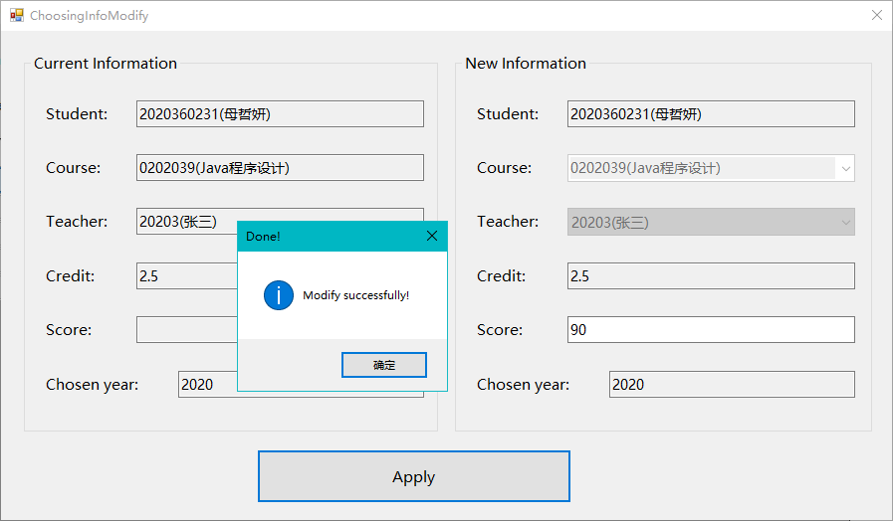

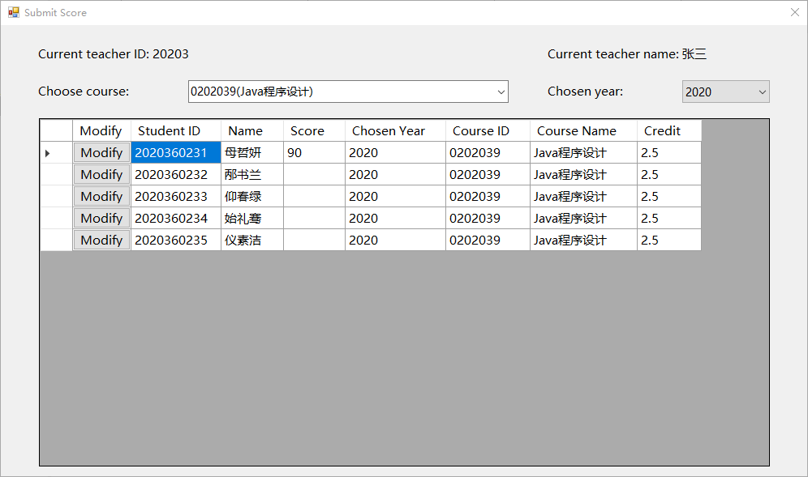

**IV Information Query**

All the Query function is in ‘Information’ menu item view. You can click it to query information.

IV.I Query student/teacher basic information

The student can only query the basic information about himself/herself. And the administrator and teachers can query all student or teacher information by input ID or name, the program will search for all records whose ID or name match the input. If the input is empty, all the records will be listed.

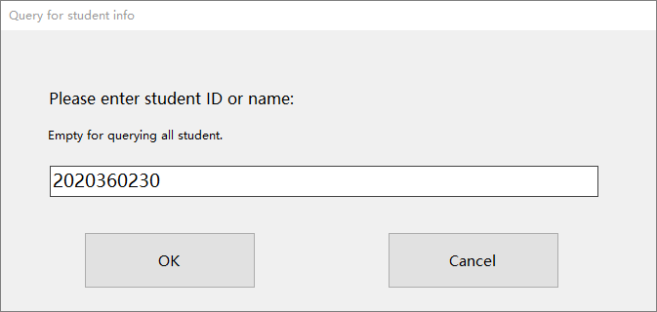

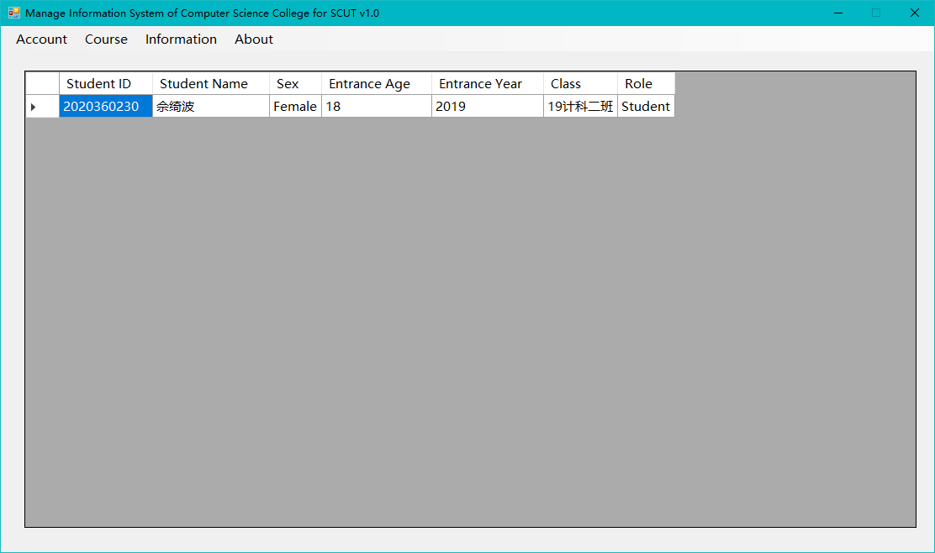

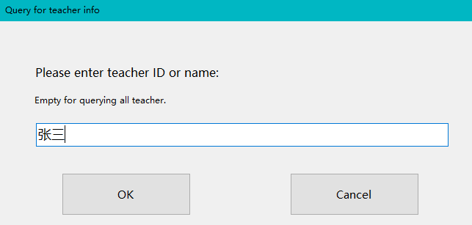

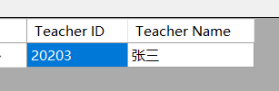

IV.II Query student score information/student course choosing information

This function can not only query score information but query course choosing information. The student can only query this information about himself/herself. And the administrator and teachers can query all student score information by input student ID or name and course ID or name, which is similar to query student/teacher basic information function.

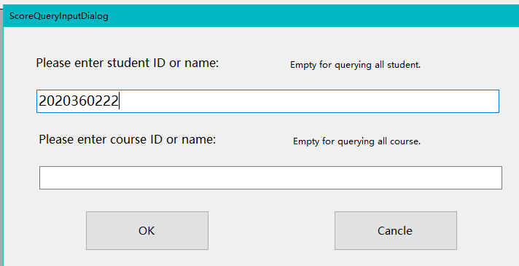

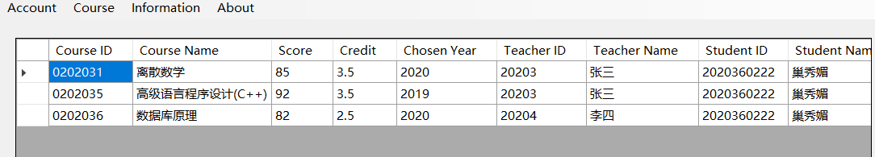

IV.III Query course information

There are two ways to query course information. The administrator can use course ID or name to query all the record about this course or use teacher ID or name to query all course record that this teacher teaches.

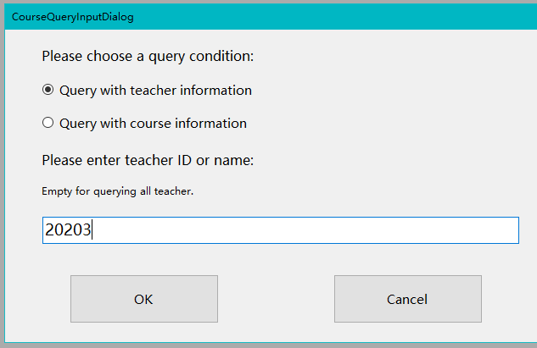

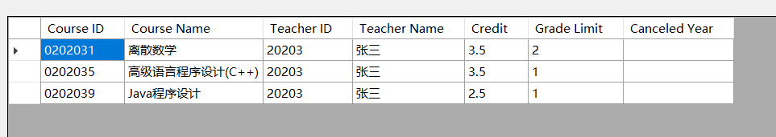

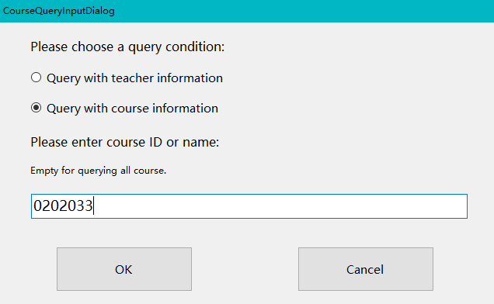

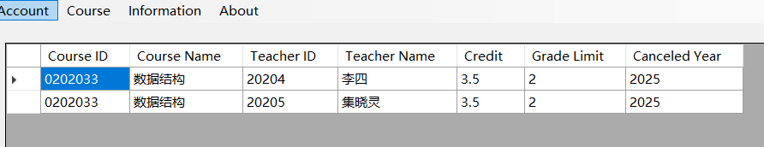

IV.IV Query average score

According to the requirement, average score of a single student, all students, students in the same class or student in the same course can be queried. And all the average score is weighted average score based on course credit. You can choosing four different average score to query by clicking ‘Information’ – ‘Query Average Score’.

IV.IV.I Average score for single student

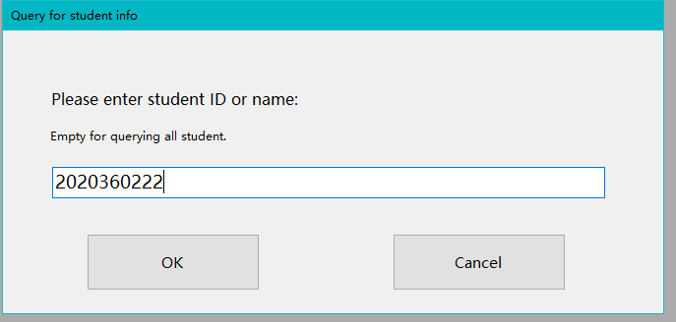

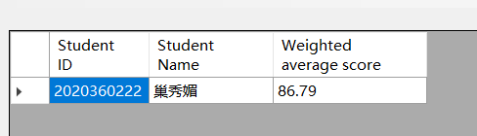

IV.IV.II Average score for all student

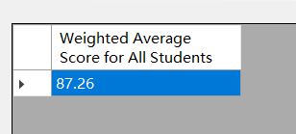

IV.IV.III Average score for students in same class

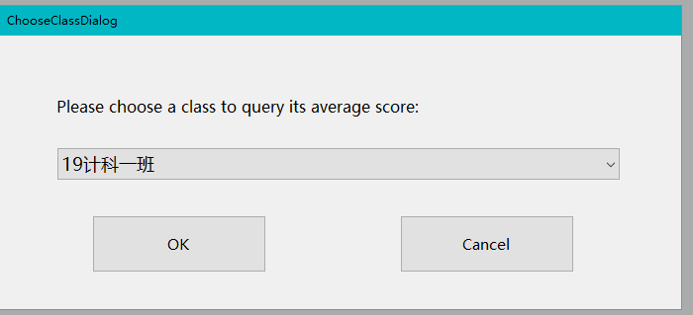

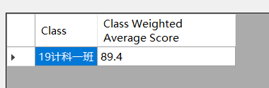

IV.IV.IV Average score for single student

